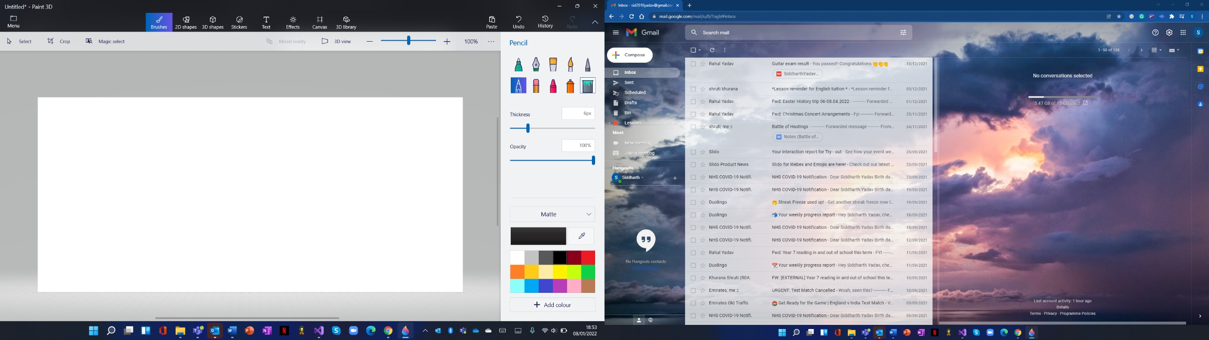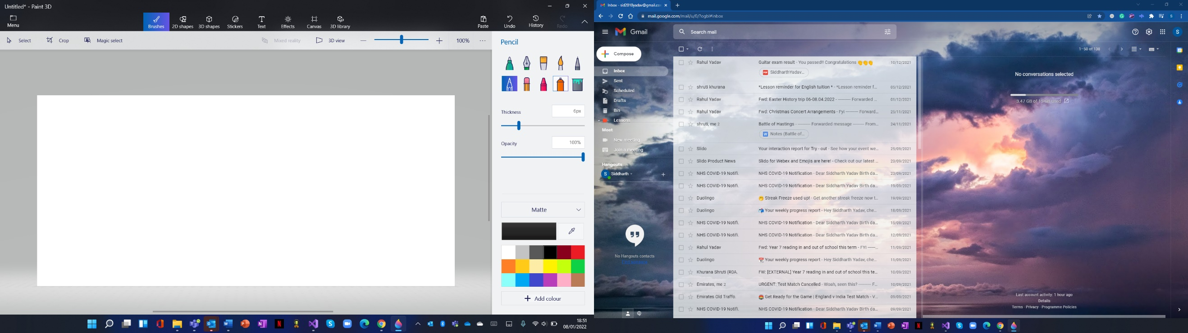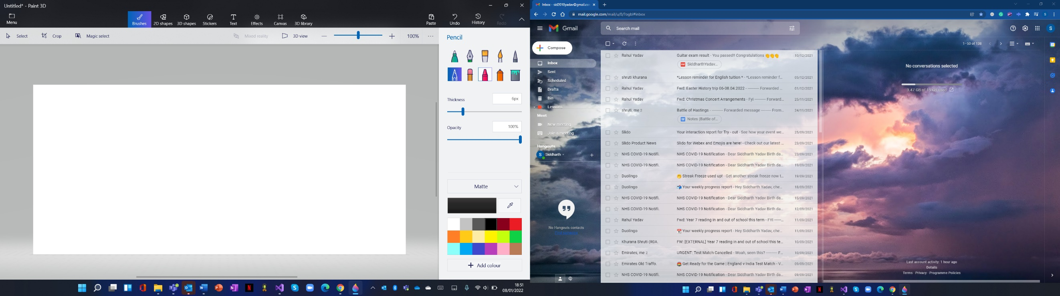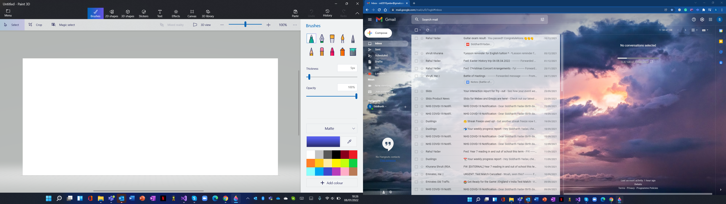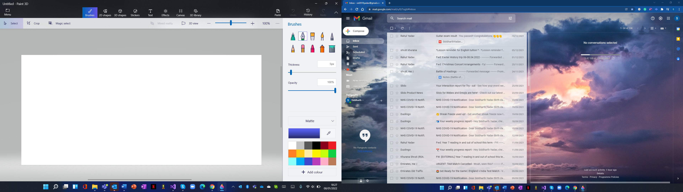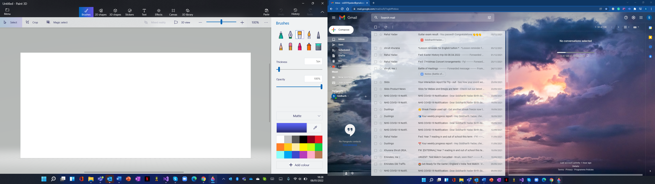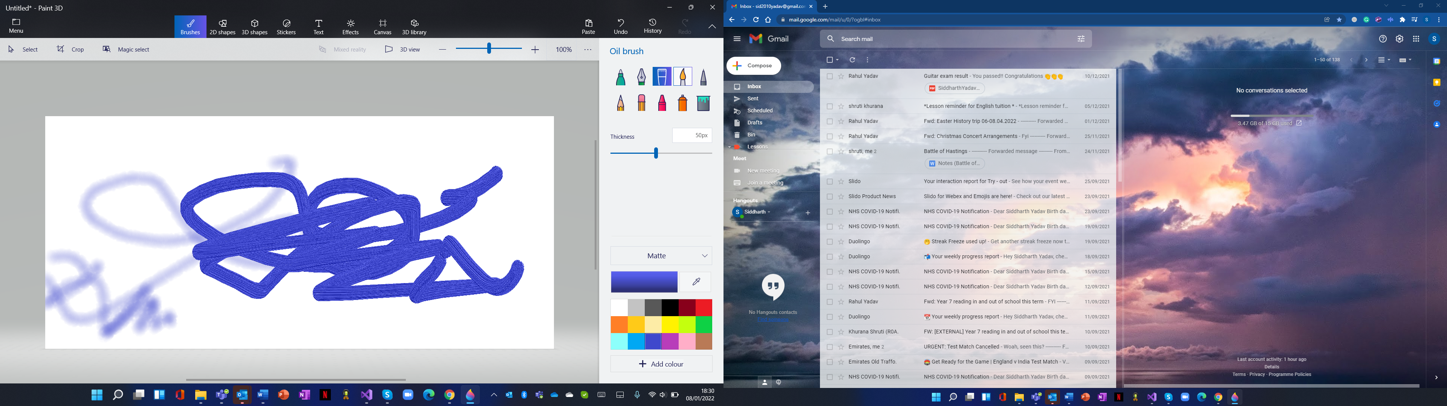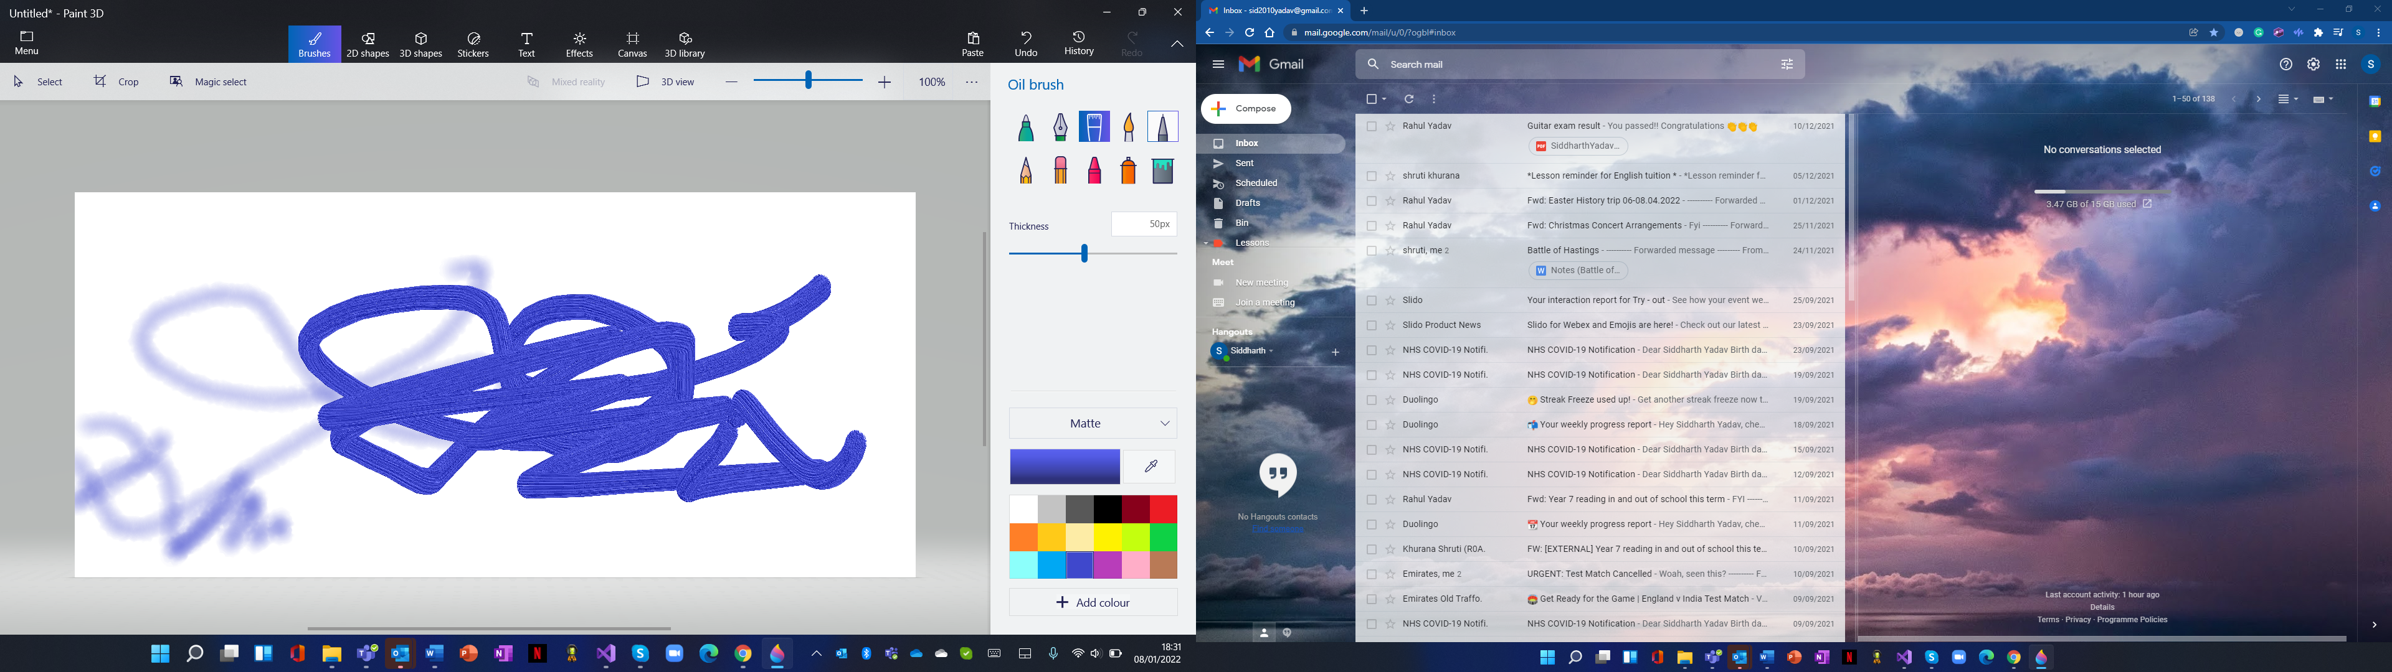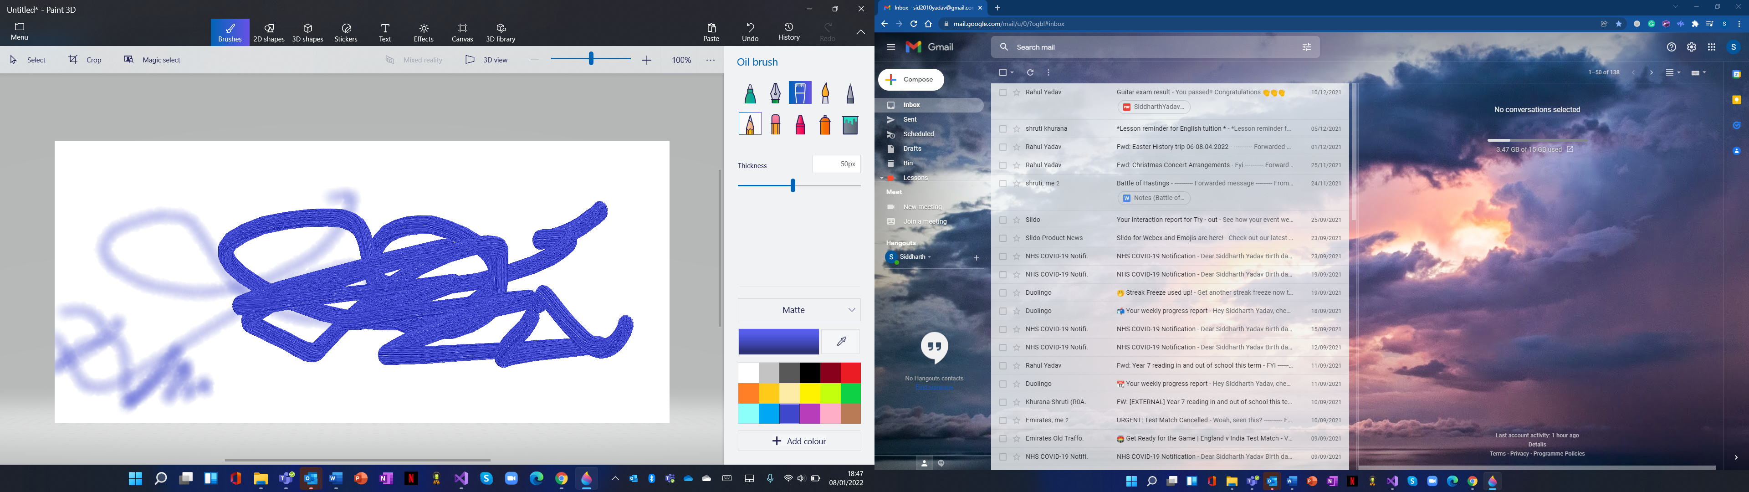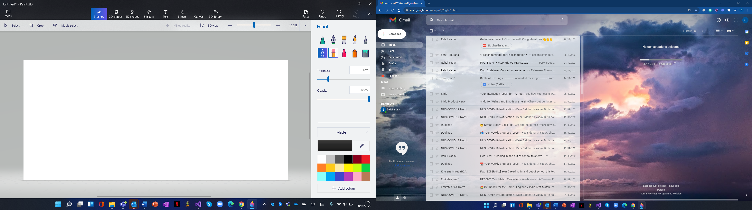

Crayon Spray can Fill

Marker Calligraphy pen Oil brush Watercolour Pixel pen Pencil Eraser